**Steps to create punch out users and Sterling Users**

## **Steps to create punch out users**

**Step 1-**  
Log into g1t4182.austin.hp.com with your credentials and then run this command pbrun su – wcsuser.  
PFS



**Step 2-**  
Place the .csv file for punch_out.csv file into /tmp folder of g1t4182.austin.hp.com using WINSCP tool by dragging file from desktop and dropping it into /tmp/ directory in g1t4182.austin.hp.com  
for ex Punchout.csv here is Punchoutcccuseridreques_SiTEL_0831.csv

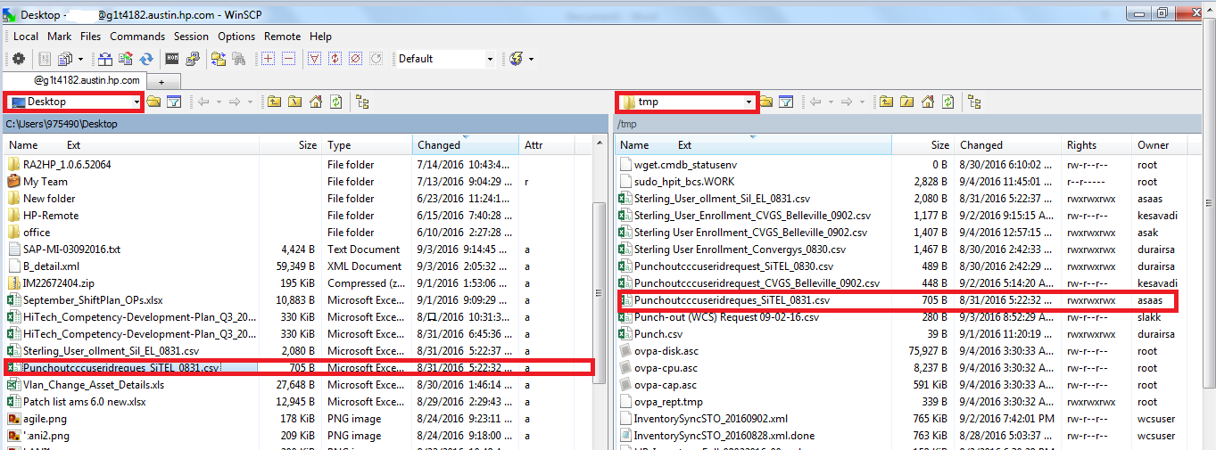

**Step 3-**   
Copy the file from /tmp directory to below mentioned directory  
/opt/apps/IBM/UserAgentDataLoad/Input  
(PFS)  
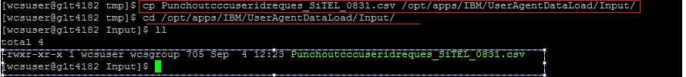

commands

copy command - cp filename directory  
ll – to list files inside respective directory.  
  
**Step 4-**  
Run ./startIntegrationServer.sh LoadAgentDataServer in /opt/apps/IBM/Sterling93/bin/  
PFB  


**Step 5-**  
After scripts executes the .csv file.  
please check .done file in /opt/apps/IBM/UserAgentDataLoad/Completed



if an error has occurred  
it is available in   
/opt/apps/IBM/UserAgentDataLoad/Error as .err and .err.data

PFB



After   
File has been processed correctly without any discrepancy now the users prescribed in .csv file can be checked in DB-Prod live   
by using these query ( random check of any user from .csv)  
 SELECT * FROM userreg where logonid='**UserID**'  
PFB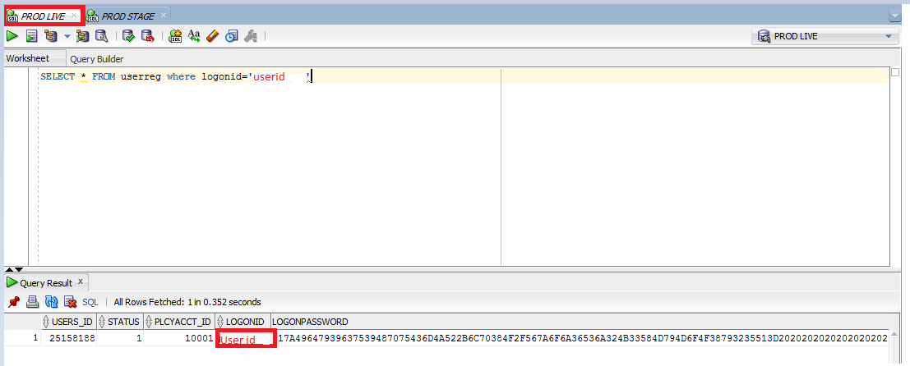  
  
  
Now the Punchout user have been created successfully using the .csv file obtained from requestor.

**Step 6-** Cross check for file

Go to /opt/apps/IBM/UserAgentDataLoad/Input and list the directory .csv file will not be available and the directory will be empty since it is processed by integrator script

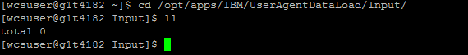

Points to be remembered

* /opt/apps/IBM/UserAgentDataLoad/Input
* /opt/apps/IBM/ UserAgentDataLoad /Working
* /opt/apps/IBM/ UserAgentDataLoad /Completed
* /opt/apps/IBM/ UserAgentDataLoad /Error
* /opt/apps/IBM/Sterling93/bin/
* ./startIntegrationServer.sh LoadAgentDataServer
* Check input and completed file to whether .csv file processed correctly.

Note  
Hurdles faced by freshers at beginning  
1.The .csv file should be punchout_aaa_bbb_ccc.csv not like aaa bbb ccc.csv  
since space will be considered in scripting and lead to error  
hence   
replace spaces by _ in renaming the file in desktop itself for safety.  
2. Be carefull while handling scripts and executing it.  
3. If the file is not processed correctly it will be removed from /input/ directory , it does not mean .csv file processed correctly.

4. Only on request from Business, users should be created from .csv file. Since it leads to HP confidential site access, it should be taken care properly.

5. Wait for .done file available till the end of the output the script writes never press CTRL+C at intermediate of processing.  
6.Please Let us know if you have any concerns and any mistake is appreciably welcomed and will be updated in next version of this document.

**For Sterling User creation**

**Step 1-**  
Log into g1t4182.austin.hp.com with your credentials and then run this command pbrun su – wcsuser.  
PFS



**Step 2-**  
Place the .csv file for Sterling.csv file into /tmp folder of g1t4182.austin.hp.com using WINSCP tool by dragging file from desktop and dropping it into /tmp/ directory in g1t4182.austin.hp.com  
for ex Sterling.csv here is Sterling_User_ollment_Sil_EL_0831.csv

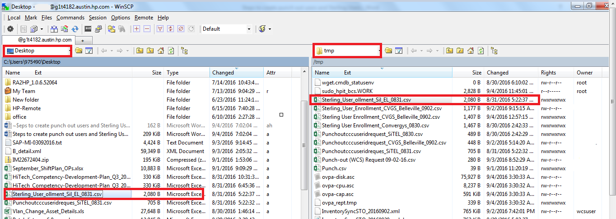

**Step 3-**   
Copy the file from /tmp directory to below mentioned directory  
/opt/apps/IBM/UserDataLoad/Input  
(PFS)  
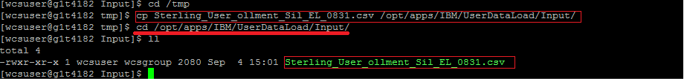

Commands--copy command - cp filename directory  
ll – to list files inside respective directory.  
  
**Step 4-**  
Run ./startIntegrationServer.sh LoadUserData_Flatfile in /opt/apps/IBM/Sterling93/bin/  
PFB  


**Step 5-**  
After scripts executes the .csv file.  
please check .done file in /opt/apps/IBM/UserDataLoad/Completed



if an error has occurred  
it is available in   
/opt/apps/IBM/UserDataLoad/Error as .err and .err.data  
PFB  
  
  


**Step 6-** Cross check for file

Go to /opt/apps/IBM/UserDataLoad/Input and list the directory .csv file will not be available and the directory will be empty since it is processed by integrator script.



**Step 7-a**  
After the file has been processed successfully and open IBM console by

<http://glbecomtran-sterling.austin.hp.com/smcfs/console/login.jsp>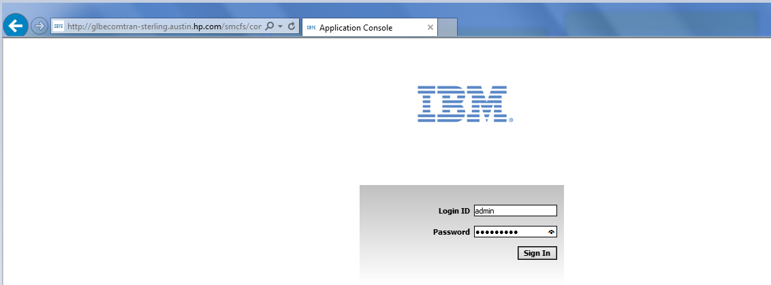

**Step7-b** Click on Configuration Tab 🡪Launch Application Manager.

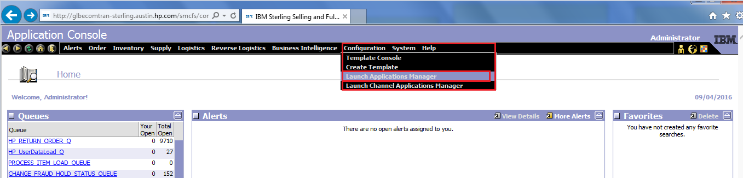

**Step 7-c** A separate window opens in that, click on Applications 🡪Application platform  
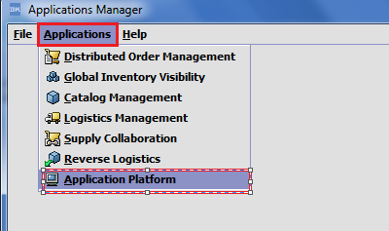

**Step 7-d**   
In Application Manager under Security 🡪 Users tab.  
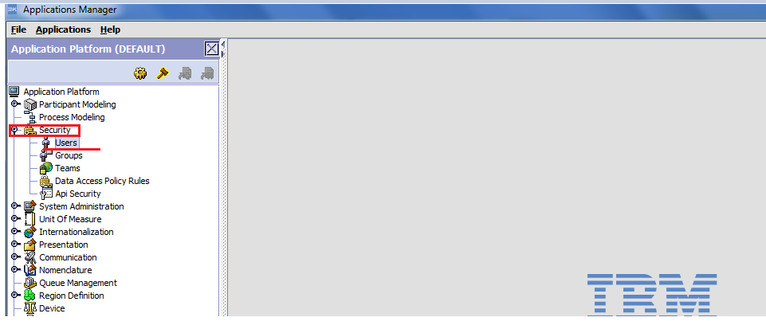

**Step 7-e**A user search window appears ,  
search for an random id from .csv file in the Console using search tool ,  
search results will update the current user id Details below.  
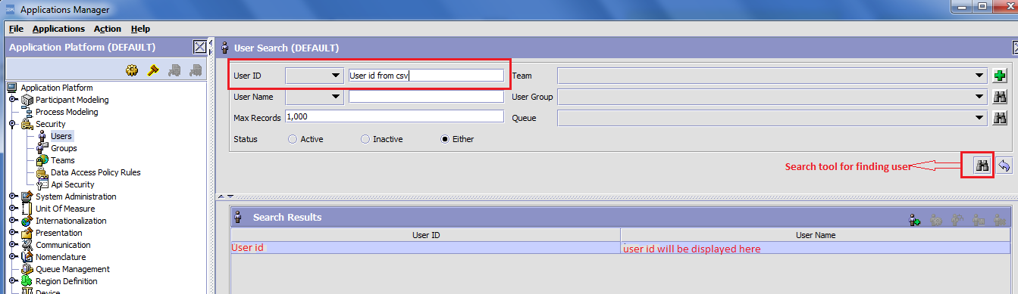When the users appear here, it is clear that the sterling agents .csv file has been created successfully.

Points to be remembered

* /opt/apps/IBM/UserDataLoad/Input
* /opt/apps/IBM/ UserDataLoad /Working
* /opt/apps/IBM/ UserDataLoad /Completed
* /opt/apps/IBM/ UserDataLoad /Error
* /opt/apps/IBM/Sterling93/bin/
* ./startIntegrationServer.sh LoadUserData_Flatfile.
* Check input and completed directory to whether .csv file processed correctly.  
    
    
  **Document Created by**

**Aashikh.A.S.  
Production Support –Operations**

**ETR HP - Offshore**